
THE LIGHTHOUSE

Newsletter for August 2015

Who among you fears the LORD and obeys the word of his servant? Let him who walks in the dark, who has no light, trust in the name of the LORD and rely on his God. Isaiah 50:10

Message from Our Pastor

Dear Sisters and Brothers in Christ,

As I sit and type this newsletter on a little folding table in what used to be our living room in duplex 3B of the family housing at Wartburg Seminary, I cannot help but smile! This journey began on Good Friday of 2002, and after 8 years of education, 5 deployments overseas (which set things back a bit) we are finally on our way to our first call!

In my first newsletter article I wanted to tell you just a little about ourselves. Catherine and I met on a blind date on August 2nd 1989 and were married Nov 30th 1991. We have three children. Nick who is 22 lives in Guttenberg, Iowa where he manages a business in town. Alex who is 19, and also lives in Guttenberg, is going to school and majoring in business at the local community college and after his graduation this year, is planning to transfer to Upper Iowa University (where I received my undergrad) to complete his four year degree. Our daughter Ellie who is 12 will of course be coming along with us and starting school in the fall. She loves to fish, and while we were on vacation during my Internship year, we came to the UP where my Internship Supervisor has a house. If we were not out seeing the sights she had a line in the water! So when she found out we had been assigned to the Northern Great Lakes Synod she was very excited! We do have one more, I can’t forget our four legged boy named Toby, he is our dog and he joined our family shortly after I returned from Iraq in 2007. He too seems to be excited for the move! As we were loading the moving truck he climbed into a cabinet as if trying to tell us he is definitely coming too!

It is definitely exciting times at the Tielbar house; there are tears of joy and tears of sadness as we say “see you later” to our friends and family. In the Army we never say “Good-Bye”. Good-byes are too final; it’s always “see you later”. If you really think about that, that has a very deep theological tone to it too. Christ’s death and resurrection overcame sin and death and gave us eternal life! Even in our faith it’s never “good-bye”; it’s always “see you later”! I have always found comfort in that.

We haven’t stopped talking about you all since the interview, and meet and greets. We are so excited to make Trinity and Zion our home. The welcome and love you showed us during that time, only affirmed what we as a family knew long before we actually met you. Trinity and Zion is where God is calling us to go! Thanks be to God!

Yours in Christ,
Pastor David

Newsletter
The August Newsletter was not adopted. ☹

Thank you!

The Marolf and Olsen families would like to thank everyone for their prayers while Joy was ill and also for your help and food donations for the beautiful luncheon after the burial service. God bless all of you.

Noisy Offering

The noisy offering for August 2nd will go to
Project Backpack.

Vacation Bible School

Vacation Bible School will be held at the United Methodist Church of St. Ignace. August 10-13, Mon-Thurs, 6 pm - 8 pm. Contact the Methodist Church if you would like to volunteer or provide money for food.

Give-aways

We are giving away a hideaway loveseat and two desks that will no longer be needed at the parsonage. Anyone from the church wishing to have them, call Lana.

Update on the Pastor

We have called David Tielbar as the minister for Trinity and Zion. David and his family should be arriving on July 28th and his first sermon should be on August 2nd.
Trinity-Zion Joint Church Picnic

We will be having a “Hello/Goodbye Picnic” for both Trinity and Zion Churches at 12:00 pm on August 23rd. It will be a pot luck held at Zion. We want to welcome David and his family to our community and we want to thank those who helped in bringing us God’s word while we were pastor-less.

Congratulations!

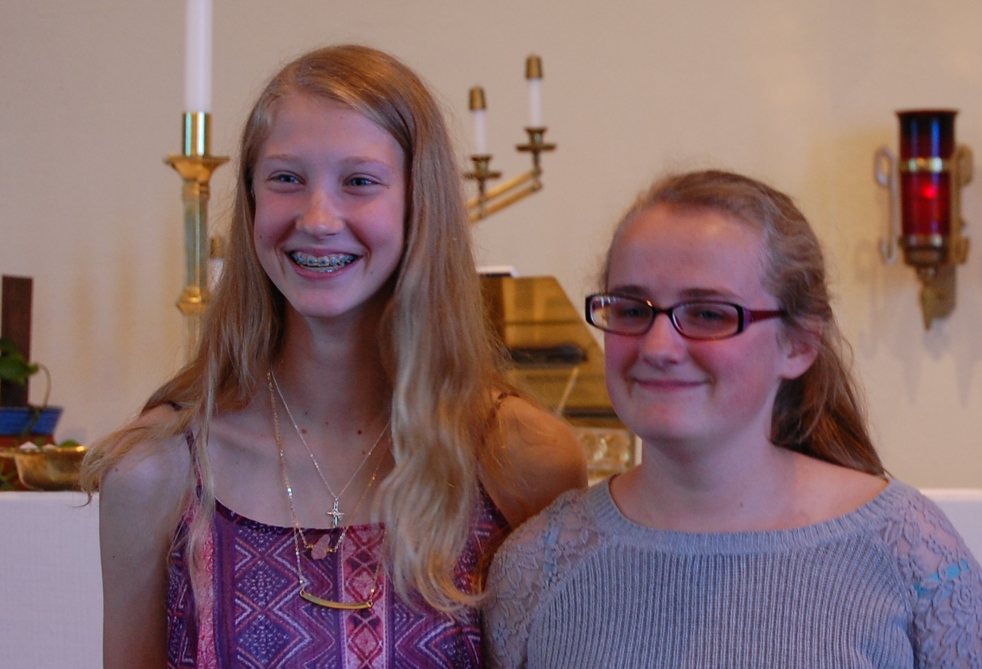

Congratulations Madison and Sarah on your confirmation!

Spartan Labels

We are now collecting Spartan Labels to raise money for Zion. Collect the UPC labels from any Spartan product and bring them to the church.

Baptismal Anniversaries

August 1 Linda Wilkins

August 1 Dianne Nelson
August 10 Aubree Vallier
August 12 Debbie Therrian
August 18 Bob Brandstrom
August 18 Wendy McCluskey
August 20 Abby LaLonde
August 28 Nevaeh Wells

Anniversaries in August

August 6 Mark & Carol Elmblad
August 6 Michael & Faith Gaubault
August 17 Bob & Debbie Brandstrom
August 17 Jon & Connie Olsen
August 23 Durance & Becky Paul
August 28 Charlie & Audrey Stenson
August 28 Les & Debbie Therrian

Birthdays in August

Aug 2 Amber Anderson
Aug 2 Molly Dandona
Aug 5 Cierra Barker
Aug 6 Joe Chalmers
Aug 6 Bailey Ryerse
Aug 7 Sandy Feleppa
Aug 8 Ethan Shepard
Aug 8 Craig Therrian
Aug 11 Adrian Coleman
Aug 11 Chelsey Coleman
Aug 11 Madison Coleman
Aug 13 Tyler Chambers
Aug 14 Stephanie Jenkins
Aug 14 Lana Lennington
Aug 14 Dottie Glashaw
Aug 16 Cole Garen
Aug 17 Shari Baron
Aug 19 Haley Dodds
Aug 21 Matthew Rogers
Aug 22 Donovan Insley
Aug 23 Lisa Rogers
Aug 24 Nicole Garen
Aug 25 Kristine Vallier
Aug 26 Gary Sorenson
Aug 27 Les Therrian
Aug 28 Duane Gamble
Aug 29 Gunnar Olsen
Aug 30 Michael Gaubault
Aug 30 Jim Ryerse
Aug 31 Savannah Barker

Trinity Worship Families

Aug 2 The Movalson Family
Aug 9 The Baron Family
Aug 16 The Chalmers Family
Aug 23 The Gustafson Family
Aug 30 The Rose Family

Zion Funeral Committee Aug - Nov

Team Leader: Linda Wilkins (430-1465)
Co-leader: Rita LaVake (906) 298-0005

Servants for Zion

Ushers & Greeters
Aug 2 Judy Ryerse & Marialana Nygard
Aug 9 Max Coburn & Lorraine Graham
Aug 16 Sandy & Fred Feleppa
Aug 23 Mike Lehto & Mike Herman
Aug 30 Les & Debbie Therrian

Lectors
Aug 2 Rita LaVake
Aug 9 Loni LaJoice
Aug 16 Betsy Turf
Aug 23 Lorraine Graham
Aug 30 Sandy Feleppa

Communion Assistants
Aug 2 Fred Feleppa
Aug 9 Jerry Fenlon
Aug 16 Lana Lennington
Aug 23 Nicole Garen
Aug 30 Lorraine Graham

Altar: Judy Ryerse
Money Counters: Lana Lennington & Nicole Garen

August 2nd we will be doing the service at Long-Term Care. Please help out if you can.

Council Meetings

Trinity Council Meeting – 6:00 pm, August 17th
Zion Council – 6:30 pm, August 18th

Zion’s Council Members

President: Lana Lennington 643-6576
Vice-President Paul Shepard 984-2069
Secretary: Lorraine Graham 643-8419
Co-Treasurers: Dawn Akers 643-7552
Co-Treasurers: Lana Lennington 643-6576
Fred Feleppa 643-6793
Jerry Fenlon 643-8730
Nicole Garen 298-0490
Tim Idalski 643-6574

Trinity’s Council Members

President: Jerri Rose 292-5570
Vice-President Tracy Movalson 292-5581
Secretary: Sharon Chalmers 292-5440
Treasurer: Pega Kennedy 292-5633
Co-Treasurer: Jim Rose 292-5570
Financial Secretary: Joe Chalmers 292-5433
WELCA: Pega Kennedy 292-5633
John Kennedy 292-5633
Jim Dyer 292-5433
Lois Movalson 292-5581

Zion Lutheran Congregational Meeting
July 5, 2015
Lana Lennington opened the meeting at 12:05 p.m.

There was some discussion of the compensation package and the health insurance.

Mark Elmblad made a motion to call David Tielbar as our pastor. Betsy Turf second. The motion was passed unanimously.

Next Jackie Kallstrom made a motion to accept the compensation package as presented but checking to see if he has health insurance. Richard Galor seconded. The motion was passed unanimously.

The meeting was adjourned at 12:30 p.m.

Respectfully submitted,
Lorraine Graham

Zion Lutheran Council Meeting
July 14, 2015

Present: Pastor Matt Lamb, Lana Lennington, Paul Shepard, Jerry Fenlon, Lorraine Graham, Dawn Akers and Fred Feleppa.

Lana Lennington opened the meeting at 6:35 p.m.

Pastor Lamb read devotions from this month’s Lutheran.

Pastor Lamb presented his final report.

The Treasurer’s Report was accepted as presented.

The Secretary’s Report was accepted as presented

Old Business:

Lorraine had some questions regarding the record book but would wait until the meeting was over to talk to Pastor Lamb and Lana.
Jerry stated that new parsonage window should be done by Labor Day. We will be sending a thank-you to the donor of the funds required.

New Business:

The new pastor will arrive on the 28th. The moving van will arrive on the 29th. We need to put in the bulletin requesting any available people to come help unload.

We decided on next month’s calendar. Council will meet on the 18th and we will have a “Hello-Goodbye” picnic on August 23rd to welcome David and his family to the community and to thank Pastor Matt and all who provided the pulpit supply for their help in the past year. Lorraine needs to invite them.

Pastor Matt suggested we ask David to provide the pastor’s article for the August newsletter.

Someone wants to rent chairs and Dawn stated there was a list of charges by the secretary’s office. Lana stated that Relay for Life would be borrowing chairs for Saturday.

We went through the mail. Some things will be kept for Pastor David. We decided against E-Church Giving and putting our name into the Yellow Book.

Paul suggested that we could do a church cook-book as a way of making money. We have a lot of good cooks in the congregation and cook-books are very popular.

Jerry brought us up-to-date on the repairs to the parsonage. Most are already finished.

There was a question as to the backboard of the basketball hoop. It was thought that someone donated money to get it fixed.

Jerry stated that the feeding of the U.P. students went very well. Any left-overs will be used on Sunday for the potluck.
The food was provided with WELCA funds and donations.

Dawn stated there was a Workshop on August 29th about budgeting. She thought that she, Lana and Pastor David should go to it. Lana agreed to go.

There was a discussion on getting the church signs up-dated with the new pastor’s name.

The meeting adjourned with the Lord’s Prayer at 7:50 p.m.

Respectfully submitted,
Lorraine Graham

Prayer List

(If you would like someone added to the prayer list, call the church at 906-643-7870)


Jim Dyer, Carl & Mary Belonga, LaTaunya Paquin, Phil Richel, Barb Lehto, Jackie Kallstrom, Charlie Lamoreaux, Beth Ann Amacher, Joel Morabito, Joanne Truman, Greg Mitchinson, Kelli Morrison, Ric Mulholland, Jim Rose, Troy Johnston, Dave Movalson, Pega Kennedy, Jim Ryerse, Steve Ingalls, Tom Coffey, Jane Yoder, Lance Litzner, Barb LaJoice, Becky Barber, Ruth Visnaw, Jim Scott, Ernie Langstaff, and the families of Don Closs, Jerry Gallagher and Peter Matelski.

